Agentic AI: refers to artificial intelligence systems that can pursue goals, make decisions, and take actions autonomously based on their understanding of the different environment, often with a degree of independence from direct human control.

Build a product recommendation chatbot with Amazon Bedrock Agents

Hands-on with Amazon Bedrock Agents

This workshop will go through how to build a chatbot for e-commerce applications, by leveraging Amazon Bedrock Agents , you can easily configure your e-commerce APIs so that the chatbot can use them to run tasks for the user based on the discussion.
The target audience for this workshop are solution architects, software designers and developers. Previous AI/ML knowledge is not required, more information on Generative AI concepts can be found on AWS Generative AI web page.
The Labs in this workshop is expected to take around 1 hour to complete. This workshop is designed to be run in US West (Oregon) AWS region (us-west-2).

Architecture

the workshop follows a serverless architecture of Amazon Bedrock calling AWS Lambda functions which do some actions on a set of Amazon DynamoDB tables, and utilizing Knowledge Bases for Amazon Bedrock to incorporate data from files in Amazon Simple Storage Service (Amazon S3).
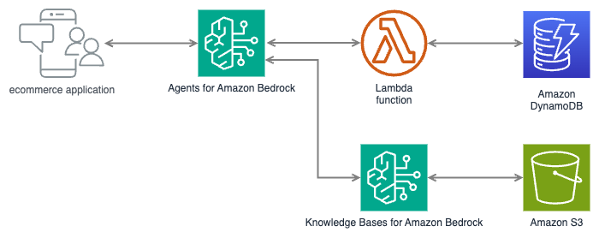

Explore Products
In this section you will create a recommender chatbot using Amazon Bedrock Agents, it helps users describe who do they want to buy the gift for and the relevant occasion, and it automatically queries an API in the form of an AWS Lambda function that is getting product information from an Amazon DynamoDB table. The agent automatically changes the API inputs to filter products based on its discussion with the user, it will ask clarifying questions to be able to determine as much inputs as possible, and at the end tries to respond with the most relevant products that are available in the DynamoDB table.
The chatbot will leverage the Lambda function API to retrieve product details based on user preferences such as gender, occasion, and category.
The workshop setup section created an Amazon DynamoDB table named producttableandapi-ws-Products-XXXX with the following attributes: product_name (partition key), category, gender, and occasion. It also defines a Global Secondary Index for each of these attributes to enable efficient querying.
Additionally, it created a Lambda function named GetProductDetailsFunction that acts as an API for retrieving product details, This Lambda function accepts query parameters such as category, gender, and occasion. It constructs a filter expression based on the provided parameters and scans the DynamoDB table to retrieve matching products. If no parameters are provided, it returns all products in the table. It has also created another Lambda function called PopulateProductsTableFunction that generate sample data to be put in the products table.
The “PopulateProductsTableFunction” has been executed already to add 100 sample product entries in the products DynamoDB table, with random combinations of product names, descriptions, categories, genders, and occasions.

Create the Agent

Now that you know the infrastructure in place, you can start creating the Agent:
- Create an Agent from Amazon Bedrock Console > Agents , you can use product-recommendation-agent as the name:
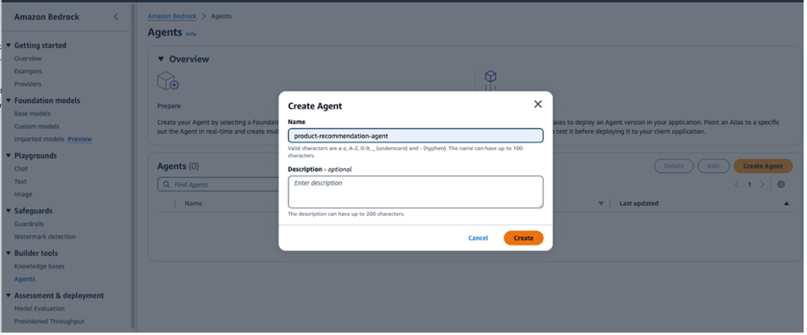
- Select Anthropic Claude Sonnet 4.5 as the model, deselect the 'Bedrock Agent Optimized' checkbox to see it
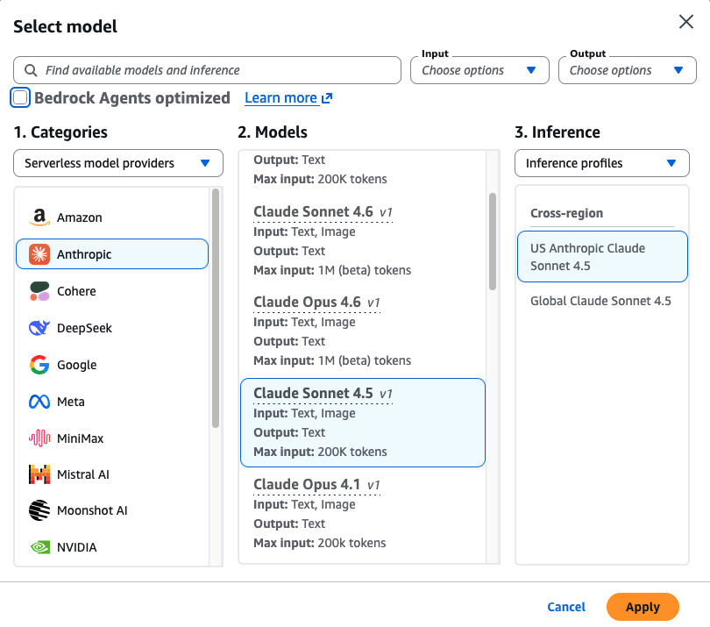
- Select Use an existing service role as the Agent resource role, then select the role starting with producttableandapi-ws-IAMRole00AmazonBedrock
- use the following as the instructions for the agent:
you are a product recommendations agent for gift products, the user is trying to buy a gift for someone and you are trying to help identify the best products based on the filters in the action groups, ask questions to identify at least one of the input filters, gender, category or occasion.
do not recommend any products that are not retrieved from the products API.
do not ask about the gender if it is obvious from the user input already.
Always start by getting the full list of products from the API so you can know the proper filter values to be used in the API parameters.
always use a single value for each filter field, and adhere to the filtration values based on the first API call.
And never tell the user about the API and its details.
These set of instructions are important to guide the Agent how to communicate with the user and how to utilize the API, this can be adjusted based on the different use cases and business scenarios as well as the available APIs.
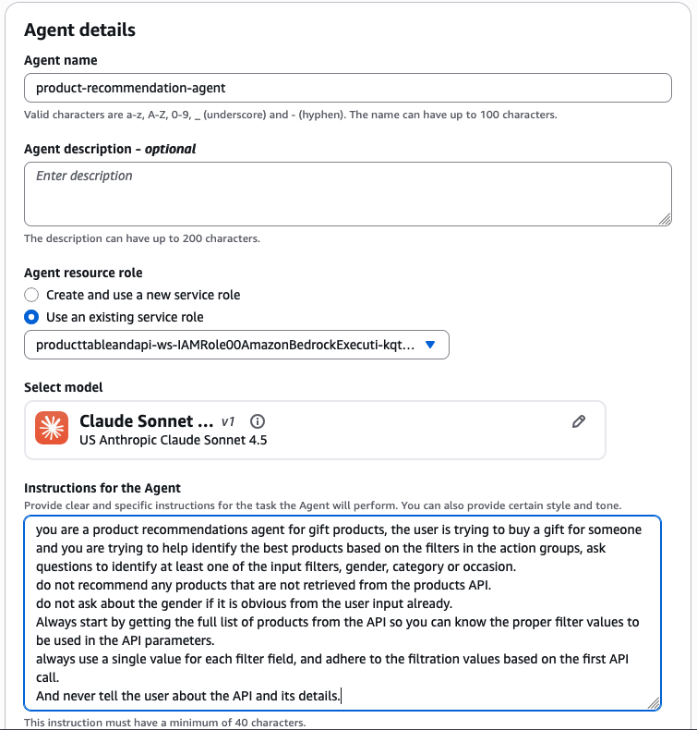
- Enable User input in Additional settings:
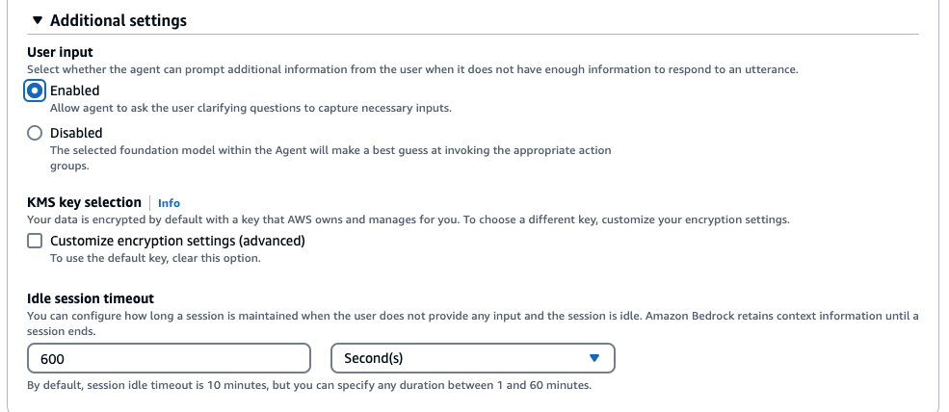
The agent's primary goal is to engage in a conversation with the user, gathering information about the recipient's gender, the occasion for the gift, and the desired category. Based on this information, the agent will query the Lambda Function to retrieve and recommend suitable products.
Important Choose “Save” on the top of the page before you proceed to next steps.

Add an Action group

- Navigate to the Action Groups section, then choose “Add” to add an Action Group to enable the Agent to invoke the Lambda Function, put the name as get-product-recommendations and choose Action Group Type “Define with API Schemas”:
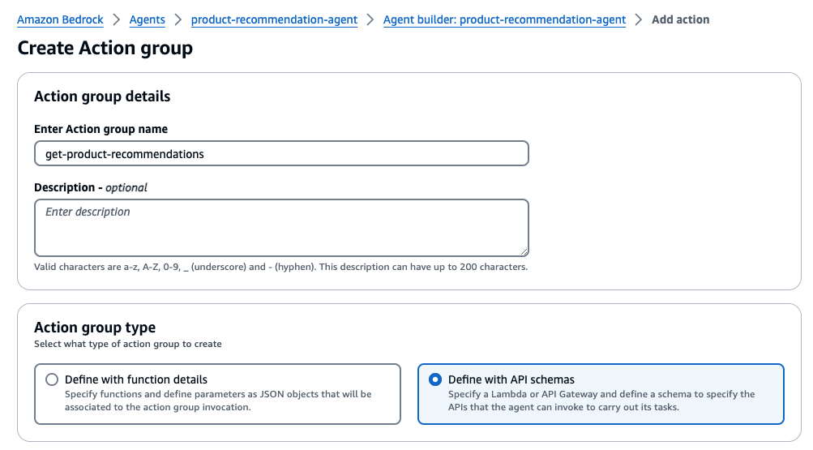
- Select the ‘GetProductDetailsFunction’ Lambda function for Action Group Invocation:
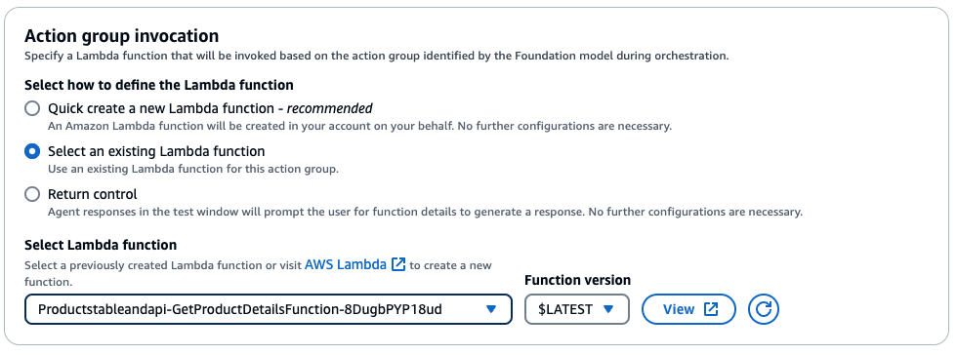
- Choose ‘Define Via inline schema editor’ for Action Group Schema:
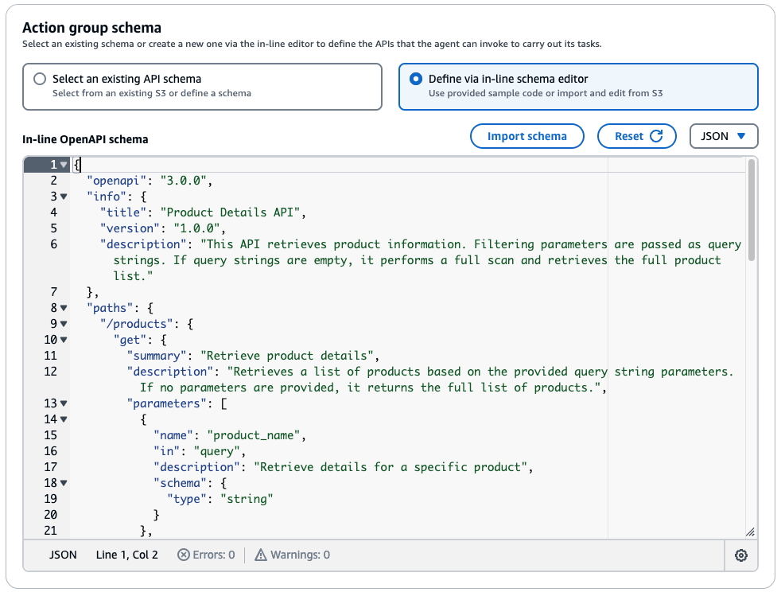
And Use the following OpenAPI schema in the in-line OpenAPI schema section:
{
"openapi": "3.0.0",
"info": {
"title": "Product Details API",
"version": "1.0.0",
"description": "This API retrieves product information. Filtering parameters are passed as query strings. If query strings are empty, it performs a full scan and retrieves the full product list."
},
"paths": {
"/products": {
"get": {
"summary": "Retrieve product details",
"description": "Retrieves a list of products based on the provided query string parameters. If no parameters are provided, it returns the full list of products.",
"operationId":"getProducts",
"parameters": [
{
"name": "product_name",
"in": "query",
"description": "Retrieve details for a specific product",
"schema": {
"type": "string"
}
},
{
"name": "category",
"in": "query",
"description": "Filter products by category",
"schema": {
"type": "string"
}
},
{
"name": "gender",
"in": "query",
"description": "Filter products by gender",
"schema": {
"type": "string"
}
},
{
"name": "occasion",
"in": "query",
"description": "Filter products by occasion",
"schema": {
"type": "string"
}
}
],
"responses": {
"200": {
"description": "Successful response",
"content": {
"application/json": {
"schema": {
"type": "array",
"items": {
"type": "object",
"properties": {
"product_name": {
"type": "string"
},
"category": {
"type": "string"
},
"gender": {
"type": "string"
},
"occasion": {
"type": "string"
},
"product_description": {
"type": "string"
}
}
}
}
}
}
}
}
}
}
}
}
- Choose “Create” to create the action group, then on the Agent builder page, Choose “Save” and then “Prepare” on the top of the page. then you can use the ‘Test Agent’ section on the right to start testing having conversations with the chatbot.
Proceed to next section to test your agent

Test the Agent
Below are example conversations, along with the chatbot's responses recommending products after calling the API:
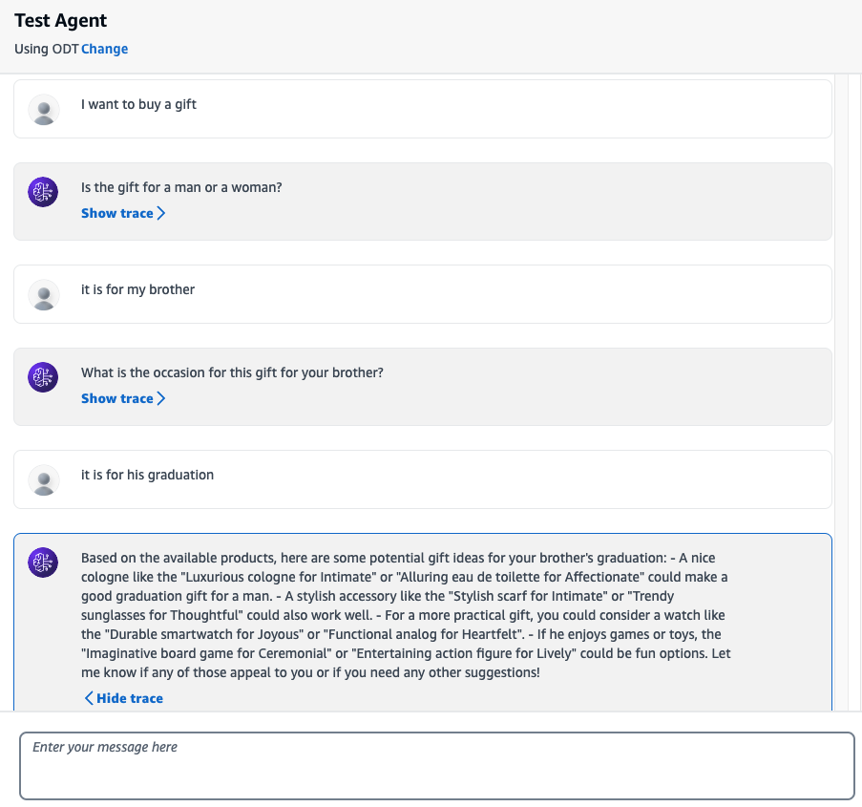
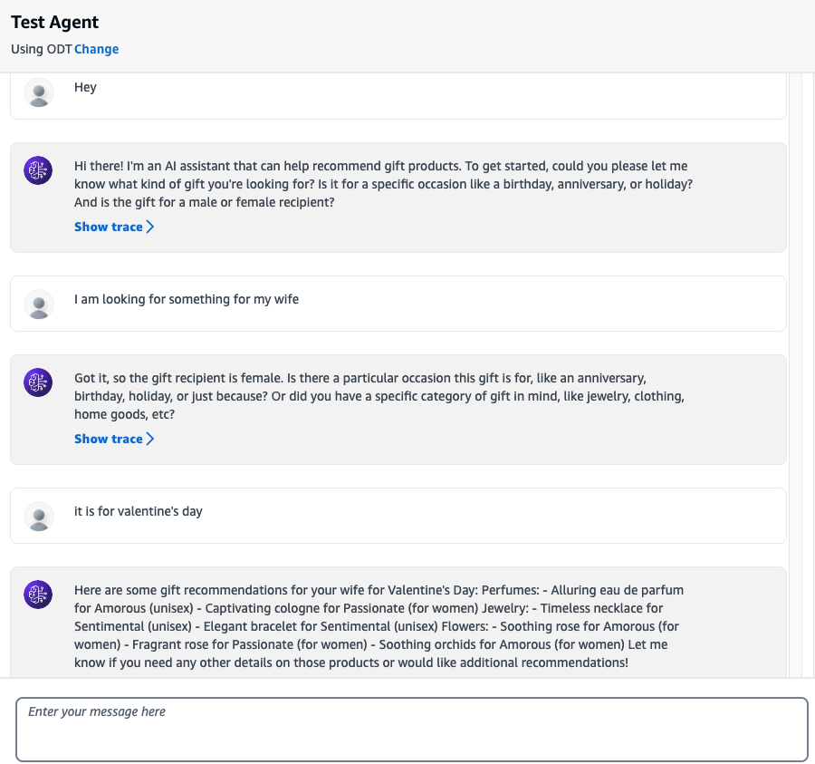

Sample Conversation and Responses:

In the sample conversation, the chatbot asks relevant questions to determine the gift recipient's gender, the occasion, and the desired category. Once it has gathered enough information, it queries the API and presents a list of recommended products matching the user's preferences.
You can see the rationale for each response by choosing Show trace >, see how the Agent decides to use different API filters based on the discussion:
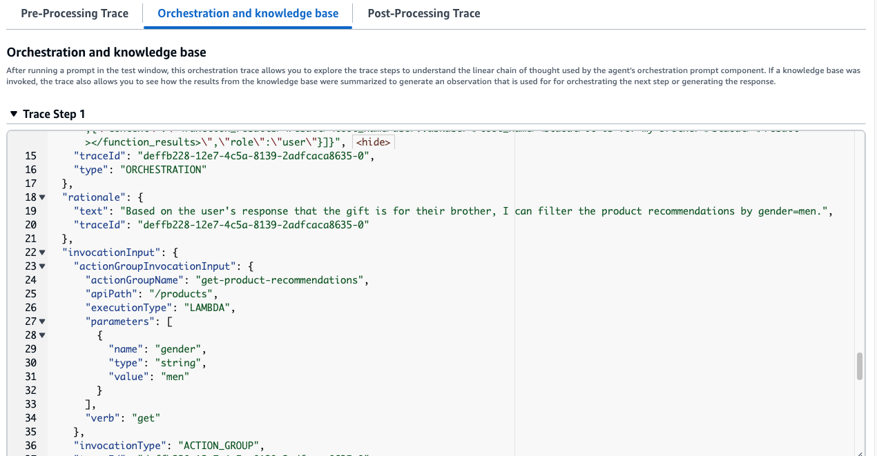
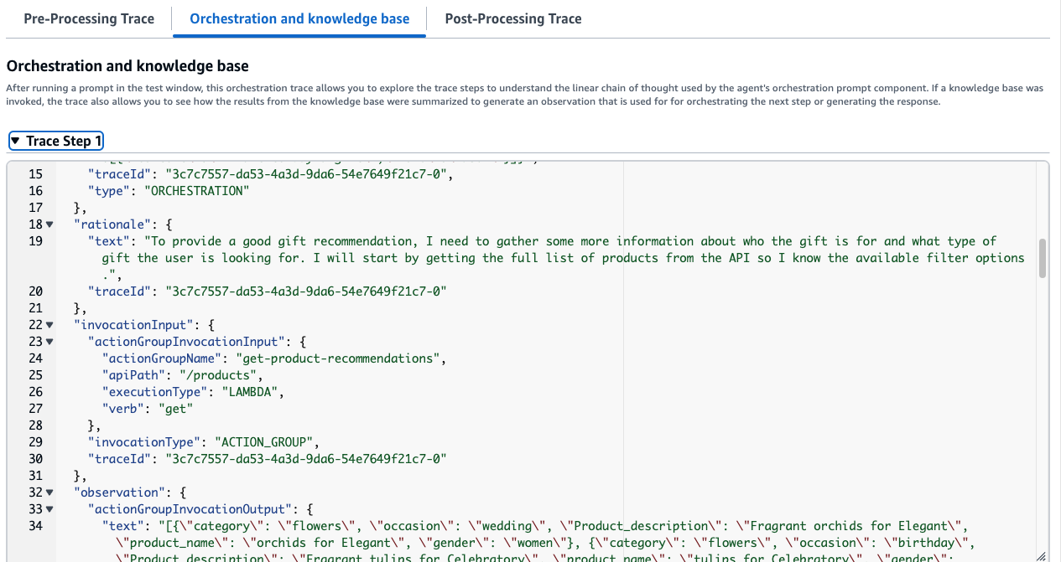

Now lets proceed to next sections to give our chatbot more capabilities

Cart Actions
In this section you will add 2 more functionalities to the agent, adding an item to a shopping cart, and getting shopping cart information.
The chatbot will leverage 2 APIs in the form of Lambda functions called GetCartFunction and AddToCartFunction, which will get the cart details and add a product to the producttableandapi-ws-Cart-XXXXX DynamoDB table, those components were created already for you as part of the workshop Cloudformation Setup.
The producttableandapi-ws-Cart-XXXXX DynamoDB table holds 2 attributes, user_id and product_name.

Edit the Agent

Now that you know the infrastructure of the cart functionalities, we need to update the agent to be able to use the new APIs. You will now update the agent to ask the user if they want to add a product to the cart, after they recommend any product(s), in order to get a user ID to add to the cart the agent will ask the user once to enter their email id.
- Choose the Agent you created in the previous section of the workshop, and choose Edit in Agent Builder
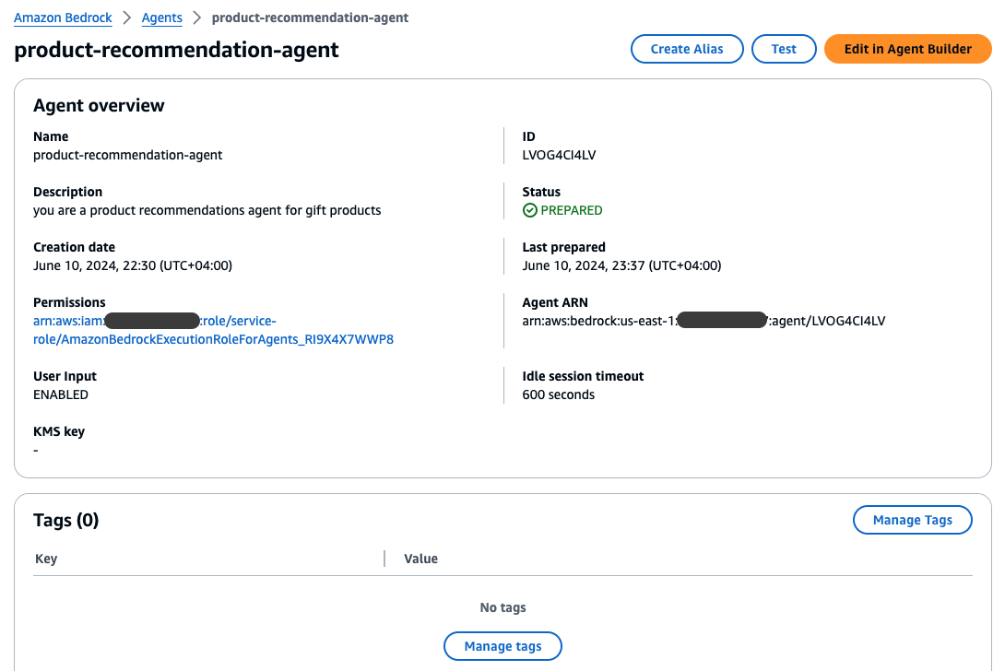
- Use the following as the updated instructions for the agent:
you are a product recommendations agent for gift products, the user is trying to buy a gift for someone and you are trying to help identify the best products based on the filters in the action groups, ask questions to identify at least one of the input filters, gender, category or occasion.
do not recommend any products that are not retrieved from the products API.
do not ask about the gender if it is obvious from the user input already.
Always start by getting the full list of products from the API so you can know the proper filter values to be used in the API parameters.
always use a single value for each filter field, and adhere to the filtration values based on the first API call.
And never tell the user about the API and its details.
After recommending products ask the user if they want to add any products to the cart, then use the add to cart API to add it, ask the user about his email and use it as user id and use it along the whole conversation and in any cart API calls, reply to the user with the user id after first cart addition to be used in later additions.
after adding an item to the cart, retrieve the cart items from the get cart API and display it to the user, the user can ask about the items in the cart at any time, use the get cart api to answer that.
These updated set of instructions are important to guide the Agent how to communicate with the user and how to utilize the APIs, this can be adjusted based on the different use cases and business scenarios as well as the available APIs.
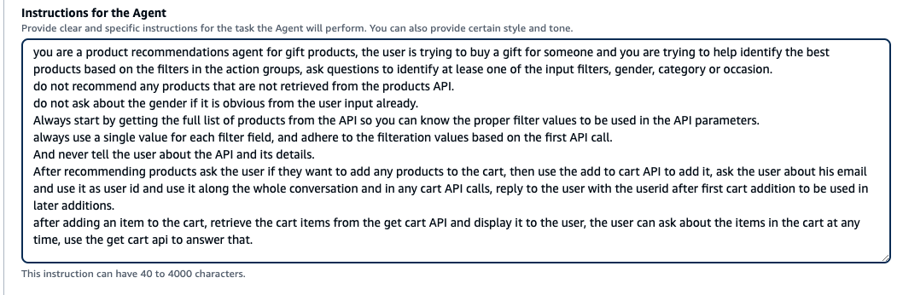
Important Choose “Save” on the top of the page before you proceed to next steps.

Add new Action groups

- Navigate to the Action Groups section, then choose “Add” to add an Action Group to enable the Agent to invoke the GetCartFunction Lambda Function, put the name as get-cart and choose Action Group Type “Define with API Schemas”:
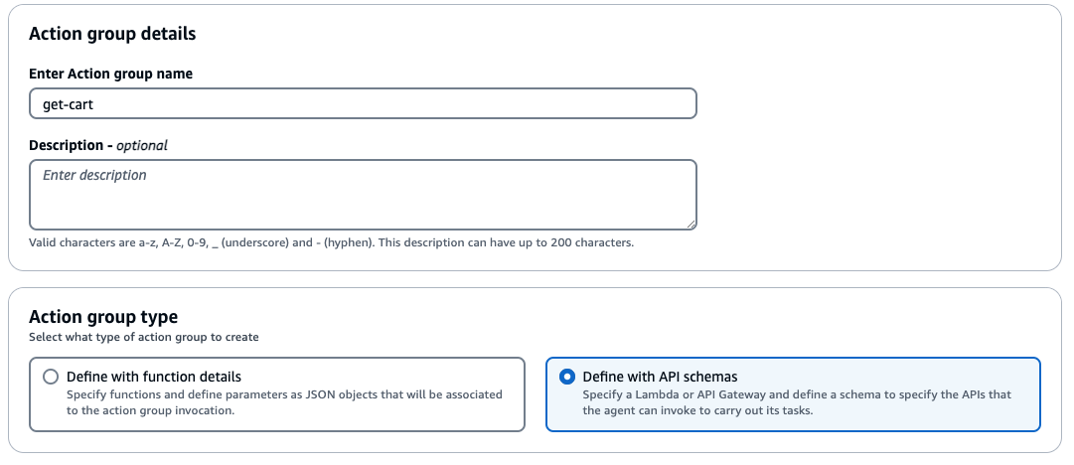
- Select the ‘GetCartFunction’ Lambda function for Action Group Invocation and Select ‘Define Via inline schema editor’ for Action Group Schema:
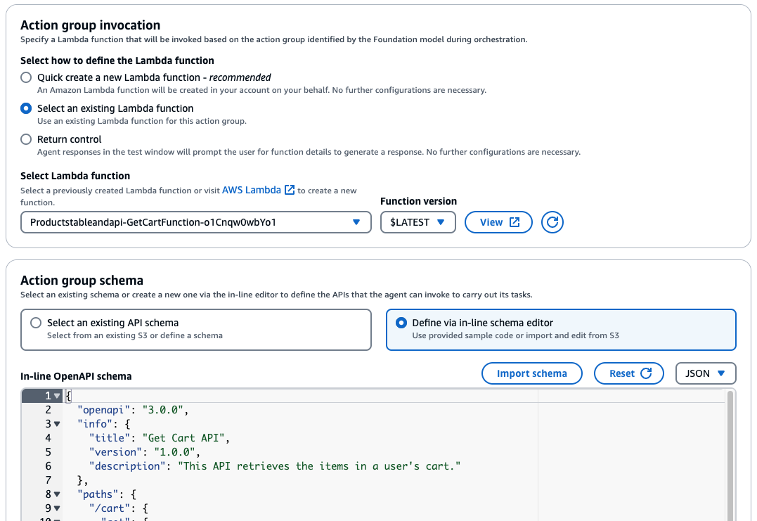

schema for get cart

And Use the following OpenAPI schema in the in-line OpenAPI schema section:
{
"openapi": "3.0.0",
"info": {
"title": "Get Cart API",
"version": "1.0.0",
"description": "This API retrieves the items in a user's cart."
},
"paths": {
"/cart": {
"get": {
"summary": "Get the user's cart",
"description": "Retrieves the list of products in the user's cart.",
"operationId":"getCart",
"parameters": [
{
"name": "userId",
"in": "query",
"description": "The ID of the user",
"required": true,
"schema": {
"type": "string"
}
}
],
"responses": {
"200": {
"description": "Successful response",
"content": {
"application/json": {
"schema": {
"type": "array",
"items": {
"type": "object",
"properties": {
"product_name": {
"type": "string"
}
}
}
}
}
}
},
"400": {
"description": "Bad Request",
"content": {
"application/json": {
"schema": {
"type": "string"
}
}
}
}
}
}
}
}
}
- Choose “Create” to create the action group.
- Add another Action Group in the Action Groups section, Choose “Add” to add an Action Group to enable the Agent to invoke the AddToCartFunction Lambda Function, put the name as add-item-to-cart and choose Action Group Type “Define with API Schemas”:
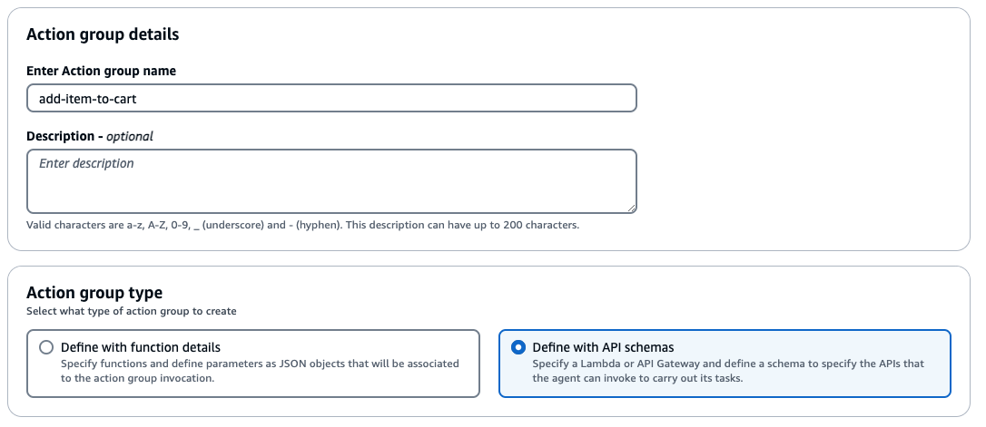
- Select the ‘AddToCartFunction’ Lambda function for Action Group Invocation and Select ‘Define Via inline schema editor’ for Action Group Schema:
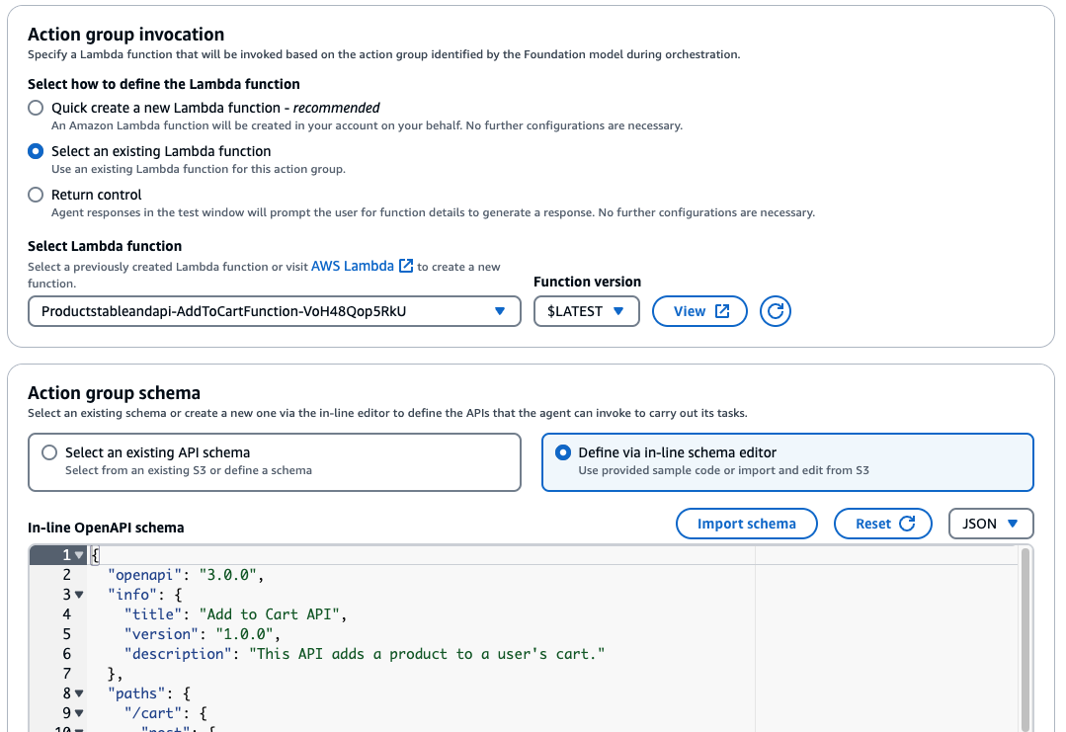

schema for add item to cart

And Use the following OpenAPI schema in the in-line OpenAPI schema section:
{
"openapi": "3.0.0",
"info": {
"title": "Add to Cart API",
"version": "1.0.0",
"description": "This API adds a product to a user's cart."
},
"paths": {
"/cart": {
"post": {
"summary": "Add a product to the cart",
"description": "Adds a product to the user's cart. If the product already exists in the cart, it returns an error.",
"operationId":"postCart",
"parameters": [
{
"name": "userId",
"in": "query",
"description": "The ID of the user",
"required": true,
"schema": {
"type": "string"
}
},
{
"name": "productName",
"in": "query",
"description": "The name of the product to add to the cart",
"required": true,
"schema": {
"type": "string"
}
}
],
"responses": {
"200": {
"description": "Successful response",
"content": {
"application/json": {
"schema": {
"type": "string"
}
}
}
},
"400": {
"description": "Bad Request",
"content": {
"application/json": {
"schema": {
"type": "string"
}
}
}
}
}
}
}
}
}
- Choose “Create” to create the action group.
- then on the Agent builder page, Choose “Save” and then “Prepare” on the top of the page. Now you can use the ‘Test Agent’ section on the right to start testing having conversations with the chatbot.

Proceed to next section to test your updated agent's new functionalities

Test the Agent
Below are example conversations, along with the chatbot's responses recommending products and adding them to the cart:
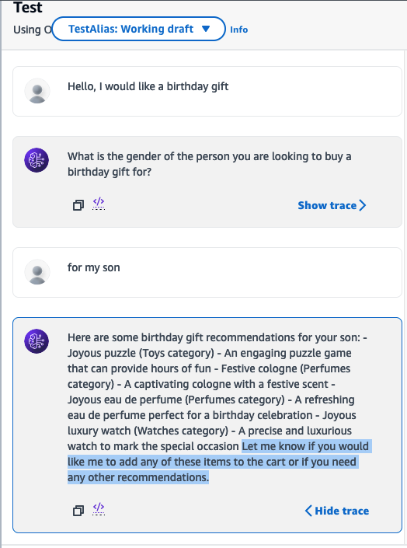
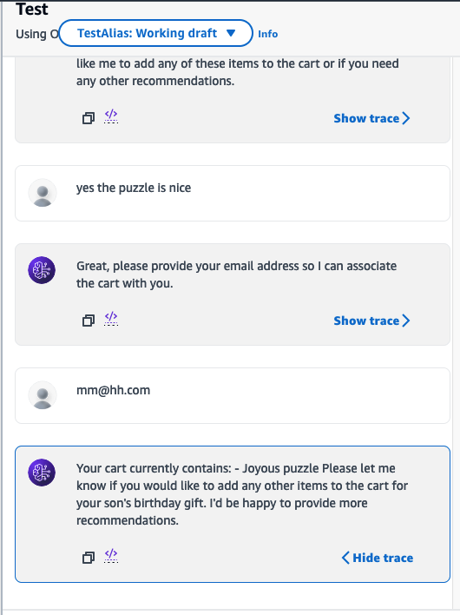
You can see the items added to the cart in the DynamoDB table producttableandapi-ws-Cart-XXXXX:
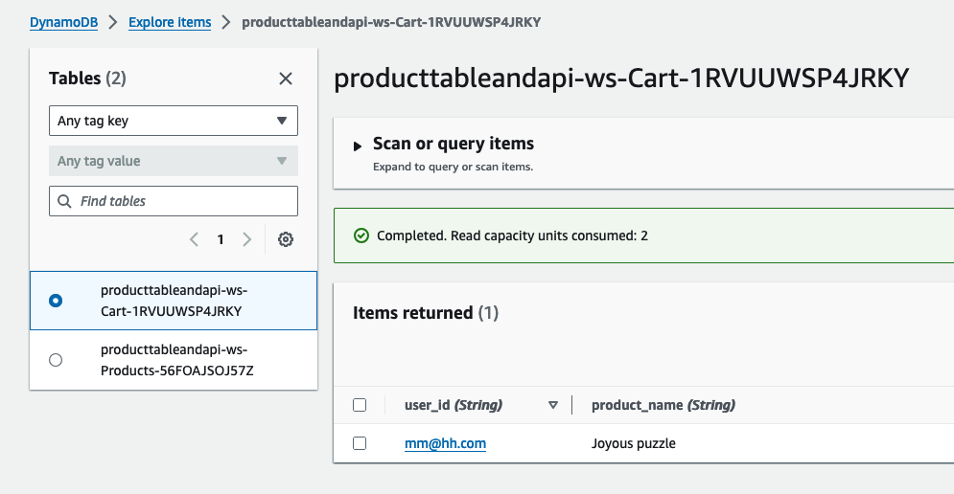

Sample Conversation and Responses:

In the sample conversation, the chatbot asks the customer if he wants to add items to the cart, and then adds the needed items. Once it has added items to the cart, it queries the get cart API and presents a list of products that are currently in the cart.
You can see the rationale for each response by Choosing Show trace >, see how the Agent decides to use different API filters based on the discussion:
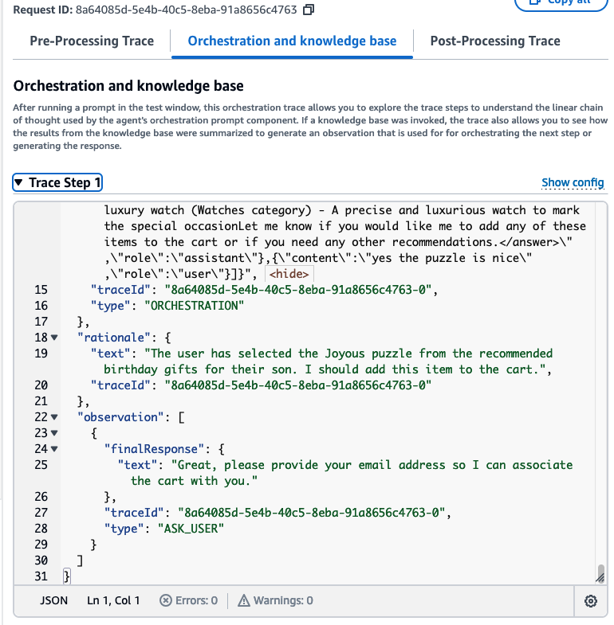
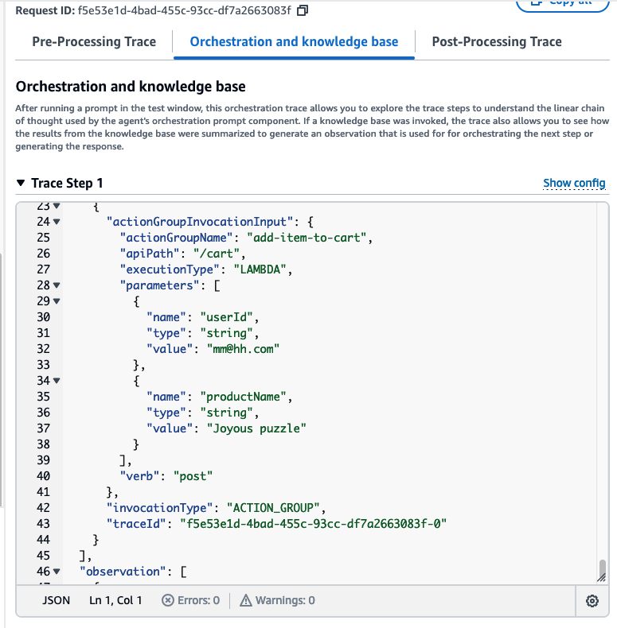
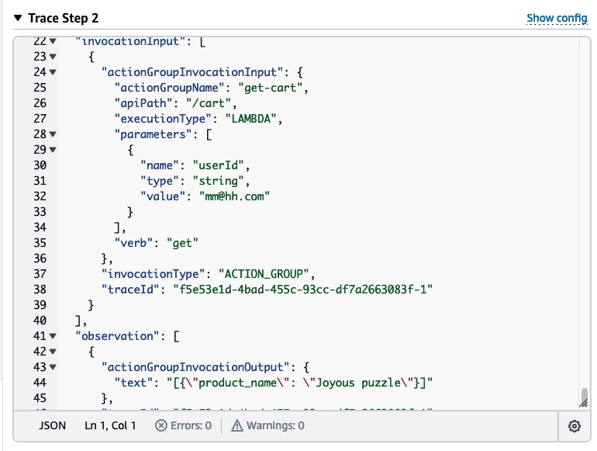

Now lets proceed to next section to give our chatbot even more capabilities

Integration with Amazon Personalize
In this section you will add one more functionality to the agent, which is adding simulated integration to Amazon Personalize .
Amazon Personalize is A fully managed Machine Learning (ML) service that uses your data to generate item recommendations for your users. It Makes it easy for developers to build applications with a wide array of personalization use cases and automates many of the complicated steps to build, train, and deploy a ML model.
And is Powered by the same ML technology used by Amazon.com – no ML expertise required.
This section aims to Leverage Amazon Personalize in the Increase Average Cart Size use case, To surface relevant items, promotions, and trending items that are likely to increase the overall order value during shopping, browsing, or at checkout. Reduce cart abandonment rates and avoid losing customers to digital browsing fatigue.
The chatbot will leverage an API that simulates "Customers who Bought x also Bought y" recommendation from Amazon Personalize, this is in the form of a Lambda functions called GetPersonalizeRecommendationFunction, which will recommend a product which was bought by other customers at the same cart as the input product, the input product being the one just added to the cart by the agent. The Lambda Function was created already for you as part of the workshop Cloudformation Setup.
Note that as part of this workshop the Lambda function GetPersonalizeRecommendationFunction is only simulating the Amazon Personalize API, it can be edited to call the Amazon Personalize API in an actual implementation scenario.

Edit the Agent

Now that you know the infrastructure of the Integration with Amazon Personalize, we need to update the agent to be able to use the new API. You will now update the agent instructions to call the get personalize recommendation API once the user chooses to add any product to the cart, using the product name to get a recommended product which was bought by other customers while buying this item.
- Choose the Agent you created in the previous section of the workshop, and choose Edit in Agent Builder

- Use the following as the updated instructions for the agent:
you are a product recommendations agent for gift products, the user is trying to buy a gift for someone and you are trying to help identify the best products based on the filters in the action groups, ask questions to identify at least one of the input filters, gender, category or occasion.
do not recommend any products that are not retrieved from the products API.
do not ask about the gender if it is obvious from the user input already.
Always start by getting the full list of products from the API so you can know the proper filter values to be used in the API parameters.
always use a single value for each filter field, and adhere to the filtration values based on the first API call.
And never tell the user about the API and its details.
After recommending products ask the user if they want to add any products to the cart, then use the add to cart API to add it, ask the user about his email and use it as user id and use it along the whole conversation and in any cart API calls, reply to the user with the user id after first cart addition to be used in later additions.
before item addition to the cart, use the get personalize recommendation API to get products other customer has bought based on the product that you just added to the cart, recommend that to the user by telling them that other customers also bought this along with the product that you just added and ask if they want to also add it to the cart as well.
after adding an item to the cart, retrieve the cart items from the get cart API and display it to the user, the user can ask about the items in the cart at any time, use the get cart api to answer that.
These updated set of instructions are important to guide the Agent how to communicate with the user and how to utilize the APIs, this can be adjusted based on the different use cases and business scenarios as well as the available APIs.
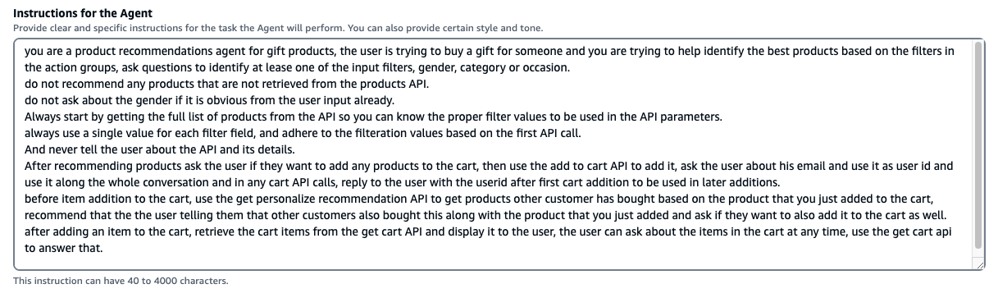
Important Choose “Save” on the top of the page before you proceed to next steps.

Add new Action groups

- Navigate to the Action Groups section, then choose “Add” to add an Action Group to enable the Agent to invoke the GetPersonalizeRecommendationFunction Lambda Function, put the name as get-amazon-personalize-recommendation and choose Action Group Type “Define with API Schemas”:
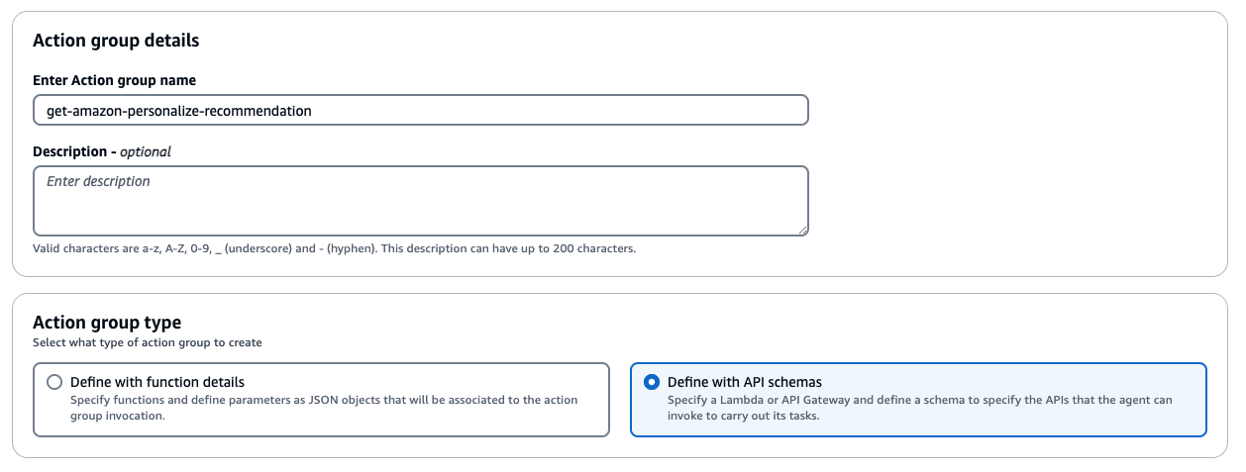
- Select the ‘GetPersonalizeRecommendationFunction’ Lambda function for Action Group Invocation and Select ‘Define Via inline schema editor’ for Action Group Schema:
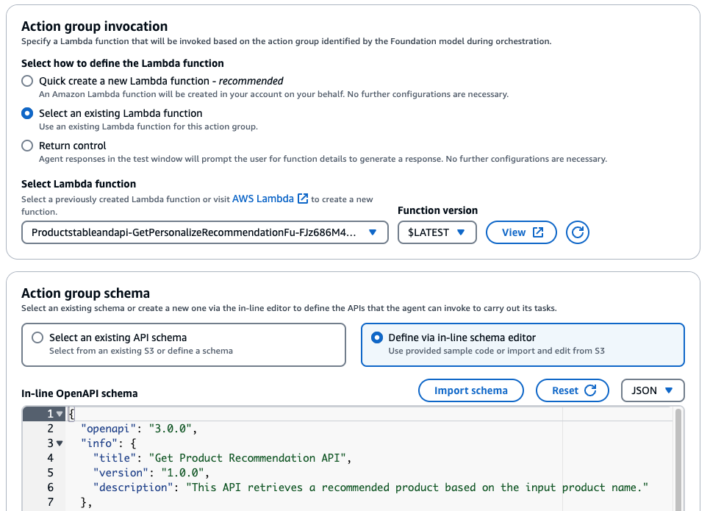
And Use the following OpenAPI schema in the in-line OpenAPI schema section:
{
"openapi": "3.0.0",
"info": {
"title": "Get Product Recommendation API",
"version": "1.0.0",
"description": "This API retrieves a recommended product based on the input product name."
},
"paths": {
"/personalize-recommendation": {
"get": {
"summary": "Get a recommended product from Amazon personalize",
"description": "Retrieves a recommended product based on the input product name using Amazon Personalize.",
"operationId":"getPersonalize",
"parameters": [
{
"name": "product_name",
"in": "query",
"required": true,
"description": "The name of the product for which to get a recommendation",
"schema": {
"type": "string"
}
}
],
"responses": {
"200": {
"description": "Successful response",
"content": {
"application/json": {
"schema": {
"type": "array",
"items": {
"type": "object",
"properties": {
"product_name": {
"type": "string"
},
"product_description": {
"type": "string"
},
"category": {
"type": "string"
},
"gender": {
"type": "string"
},
"occasion": {
"type": "string"
}
}
}
}
}
}
},
"400": {
"description": "Bad Request",
"content": {
"application/json": {
"schema": {
"type": "object",
"properties": {
"message": {
"type": "string"
}
}
}
}
}
}
}
}
}
}
}

- Choose “Create” to create the action group.
- then on the Agent builder page, Choose “Save” and then “Prepare” on the top of the page. Now you can use the ‘Test Agent’ section on the right to start testing having conversations with the chatbot.

Proceed to next section to test your updated agent's new functionalities

Test the Agent
Below are example conversations, along with the chatbot's responses recommending products and adding them to the cart, then recommending similar personalized product that other customers have purchased:
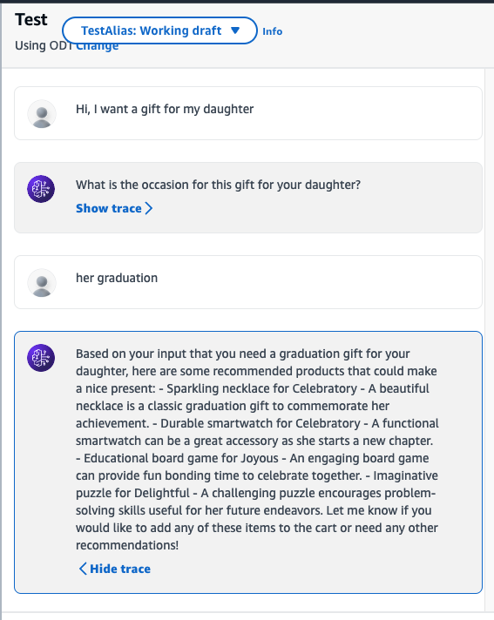
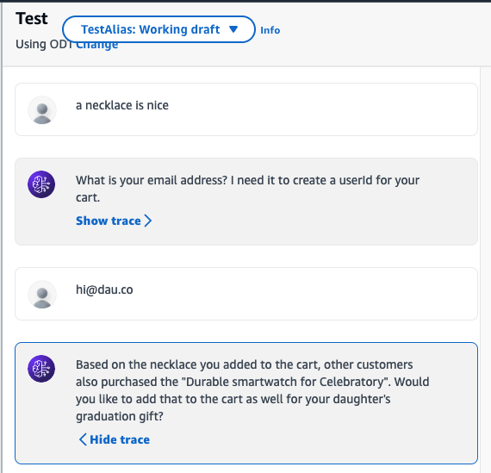
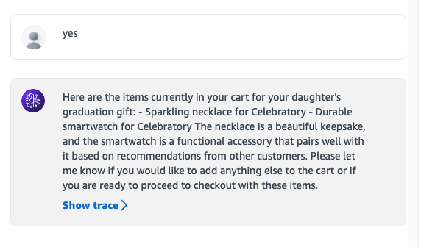

Sample Conversation and Responses:

In the sample conversation, the chatbot informs the customer that other customers who bought his item, also bought another item and asks the customer if he wants to add the recommended product to the cart as well, and then adds the needed items. Once it has added items to the cart, it queries the get personalize recommendation API and presents the result as the recommendation.
You can see the rationale for each response by selecting Show trace >, see how the Agent decides to use different API filters based on the discussion:
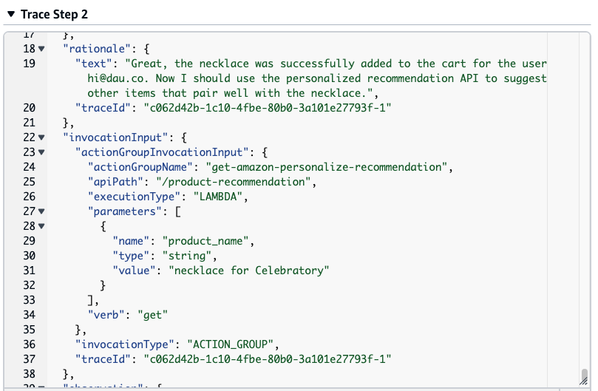
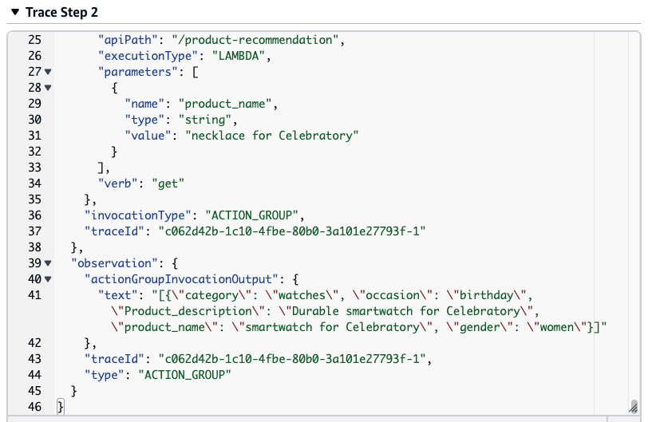

Now lets use another source of data in our Agent, in the next section we will use Amazon Bedrock Knowledge bases to suggest gift wrapping ideas.

Adding Gift Wrapping Knowledge base
In this section you will add one more functionality to the agent, which is adding the ability to generate ideas for gift wrapping based on a knowledge base using Knowledge Bases for Amazon Bedrock .
With Knowledge Bases for Amazon Bedrock, you can give FMs and agents contextual information from your company’s private data sources for RAG to deliver more relevant, accurate, and customized responses.
To equip foundation models (FMs) with up-to-date and proprietary information, organizations use Retrieval Augmented Generation (RAG), a technique that fetches data from company data sources and enriches the prompt to provide more relevant and accurate responses. Knowledge Bases for Amazon Bedrock is a fully managed capability that helps you implement the entire RAG workflow from ingestion to retrieval and prompt augmentation without having to build custom integrations to data sources and manage data flows
This section aims to Leverage Knowledge Bases for Amazon Bedrock to enhance user experience and increase loyalty by providing meaningful gift wrapping ideas.
The chatbot will leverage a Knowledge Base that was already provisioned for you as part of this workshop, having the data source as Amazon S3 bucket which contains the following file: Gift-wrapping.txt
if you are doing this workshop in your own account (Not at an AWS event) please choose the following button to deploy the knowledge base, enter BedrockKB for Stack name:
Launch in the AWS Console

Synchronize the Knowledge Base data source

- go to the Knowledge Bases for Amazon Bedrock console.
- Choose the 'GiftWrappingKnowledgeBase'
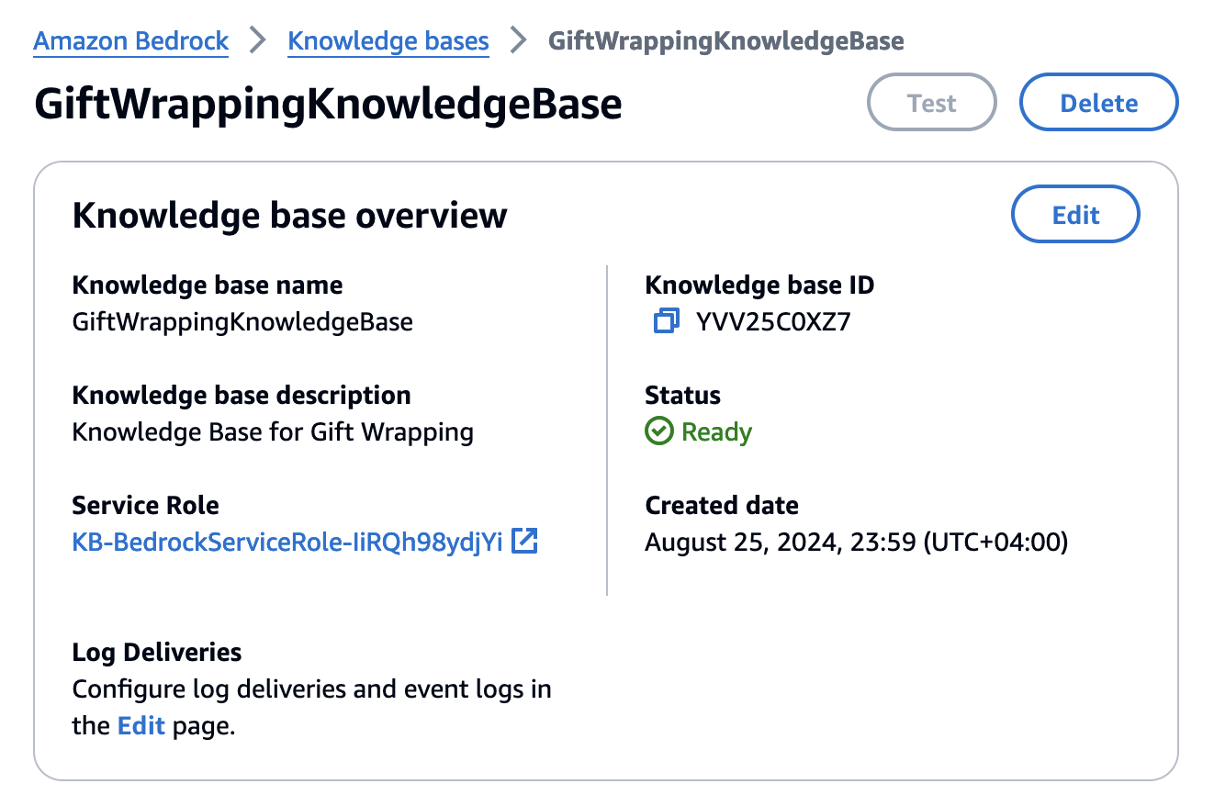
- In the Data source section, select the 'GiftWrappingDataSource' and choose Sync.
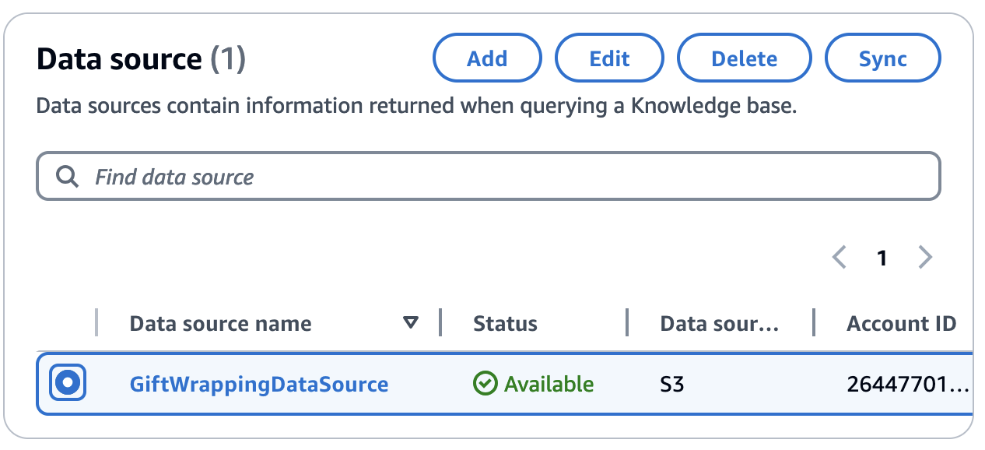
- Choose the 'GiftWrappingDataSource' to view its details and make sure the data source sync is complete from the Sync history section
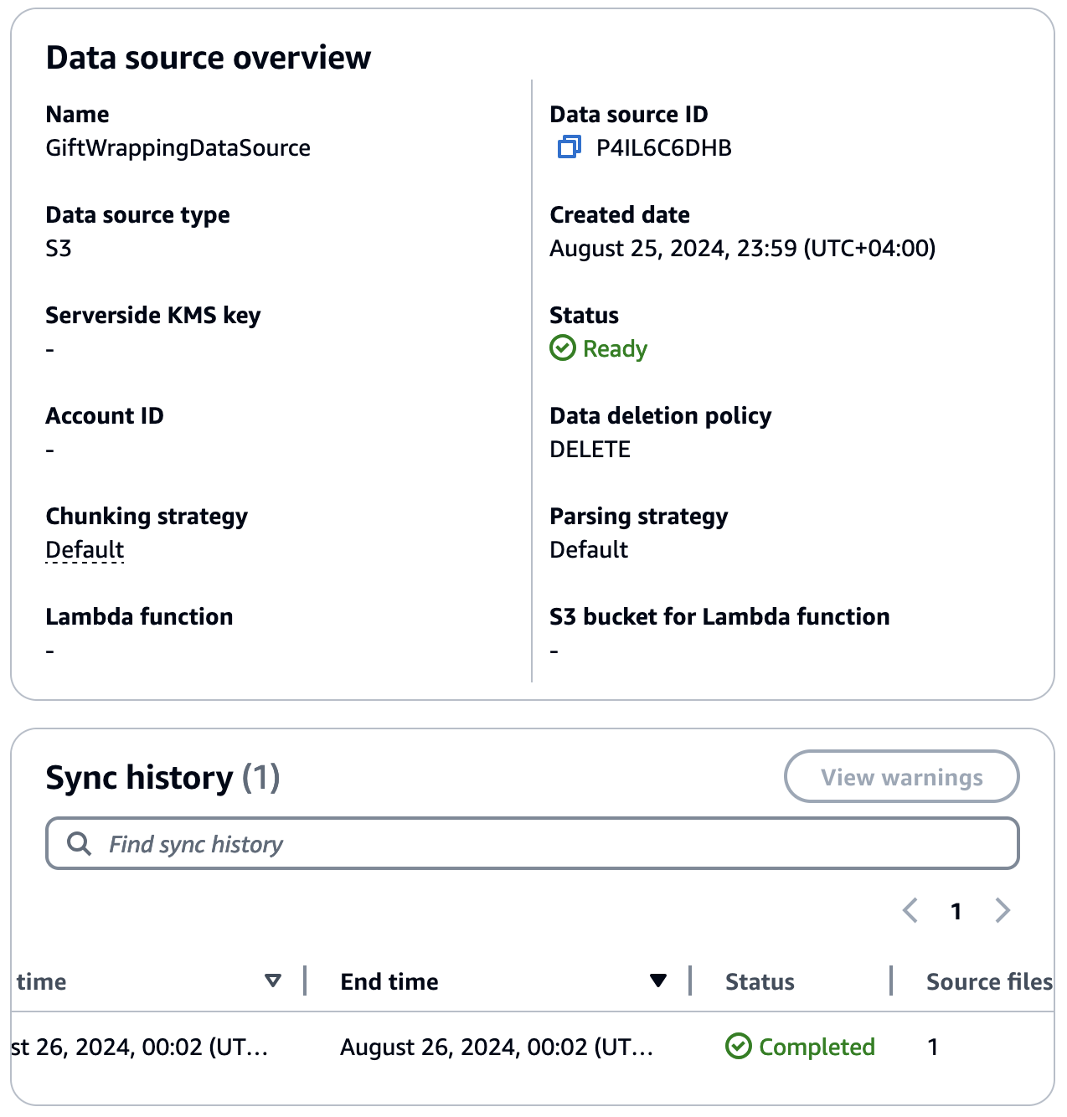

Edit the Agent

Now that you have synchronized the data source of the knowledge base, we need to update the agent to be able to use the new Knowledge base. You will now update the agent instructions to search the Knowledge base based on the products added to the cart, and suggest to the user Relevant Gift Wrapping ideas.
- Choose the Agent you created in the previous section of the workshop, and choose Edit in Agent Builder

- Use the following as the updated instructions for the agent:
you are a product recommendations agent for gift products, the user is trying to buy a gift for someone and you are trying to help identify the best products based on the filters in the action groups, ask questions to identify at least one of the input filters, gender, category or occasion.
do not recommend any products that are not retrieved from the products API.
do not ask about the gender if it is obvious from the user input already.
Always start by getting the full list of products from the API so you can know the proper filter values to be used in the API parameters.
always use a single value for each filter field, and adhere to the filtration values based on the first API call.
And never tell the user about the API and its details.
After recommending products ask the user if they want to add any products to the cart, then use the add to cart API to add it, ask the user about his email and use it as user id and use it along the whole conversation and in any cart API calls, reply to the user with the user id after first cart addition to be used in later additions.
before item addition to the cart, use the get personalize recommendation API to get products other customer has bought based on the product that you just added to the cart, recommend that to the user by telling them that other customers also bought this along with the product that you just added and ask if they want to also add it to the cart as well.
after adding an item to the cart, retrieve the cart items from the get cart API and display it to the user, the user can ask about the items in the cart at any time, use the get cart api to answer that.
Before the end of the conversation ask the user if they want you to suggest gift wrapping ideas for the products in the cart, and get the wrapping ideas based on the gift wrapping knowledge base.
These updated set of instructions are important to guide the Agent how to communicate with the user and how to utilize the APIs, this can be adjusted based on the different use cases and business scenarios as well as the available APIs.
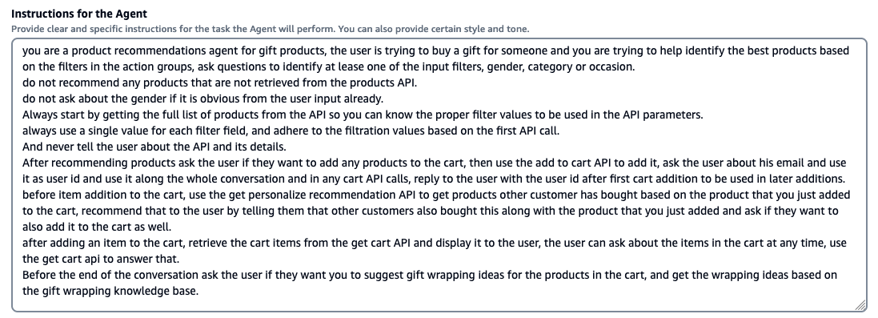
Important Choose “Save” on the top of the page before you proceed to next steps.

Add new Knowledge Base to the Agent

- Navigate to the Knowledge Bases section under the Agent, then choose “Add” to add an Knowledge Base to enable the Agent to use the Gift Wrapping knowledge base.
- Select the knowledge base 'GiftWrappingKnowledgeBase' and choose Action Group Type “Define with API Schemas”
- Add the following instructions as the 'Knowledge base instructions for Agent':
This is a gift wrapping knowledge base for ideas on how to wrap gifts based on the gift details the occasion and its recipient
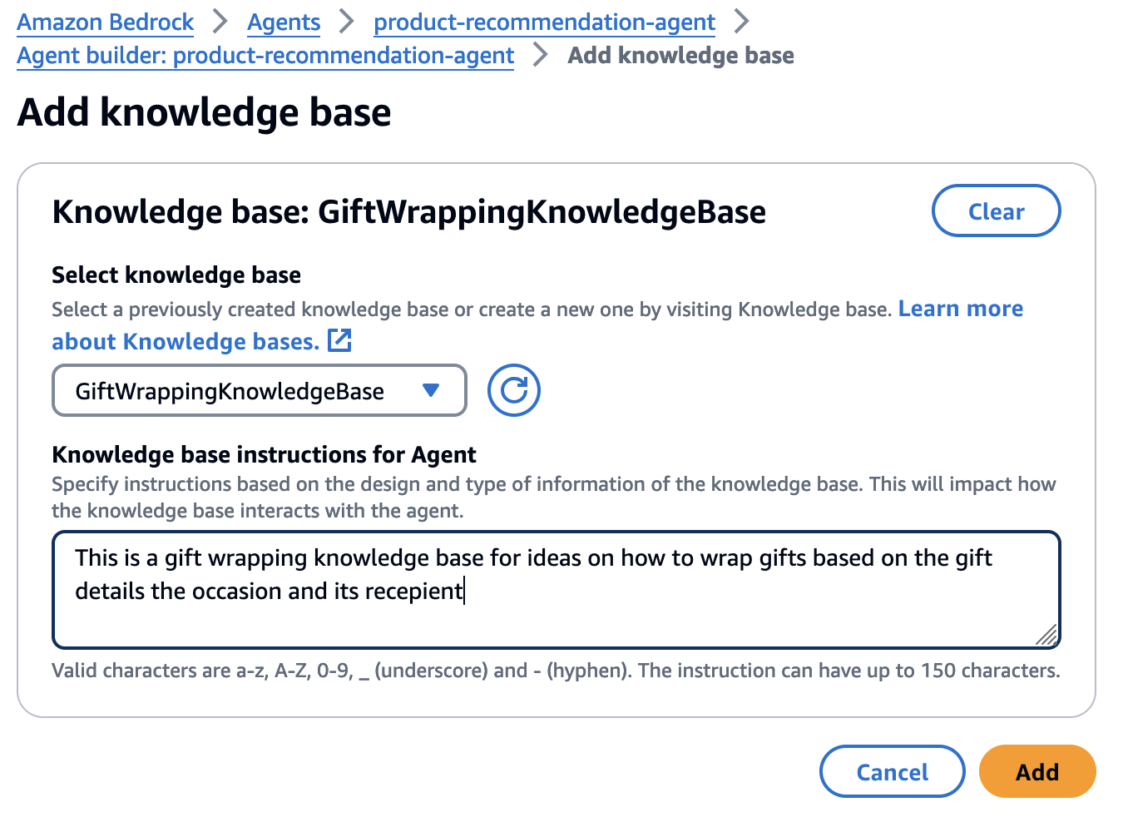
- Choose Add to add the knowledge base to the agent.
- then on the Agent builder page, Choose “Save” and then “Prepare” on the top of the page. Now you can use the ‘Test Agent’ section on the right to start testing having conversations with the chatbot.

Proceed to next section to test your updated agent's new functionalities

Test the Agent
Below are example conversations, along with the chatbot's responses recommending Gift Wrapping ideas:
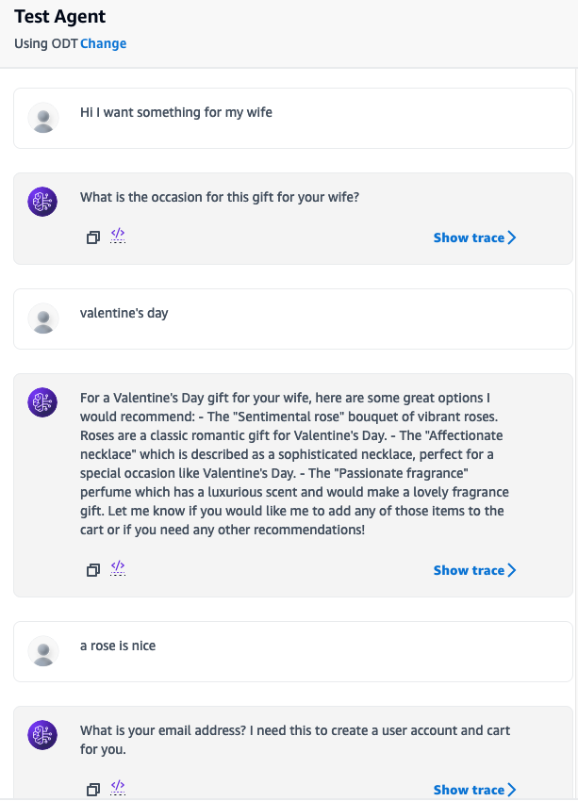
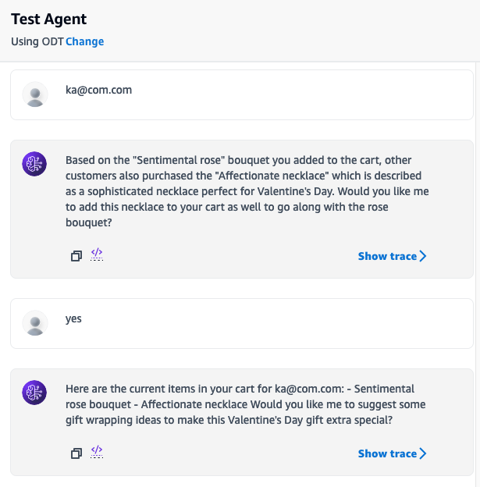
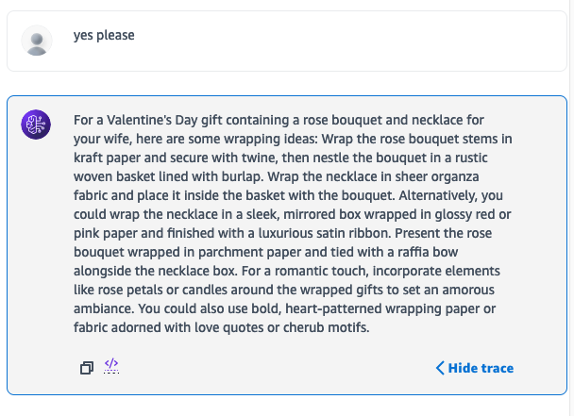

Sample Conversation and Responses:

In the sample conversation, the chatbot suggests to the customer if they want some gift wrapping ideas, and when the customer accepts, it queries the knowledge base to get ideas for gift wrapping relevant to the products the user has added to the cart.
You can see the rationale for each response by selecting Show trace >, see how the Agent decides to use different API filters based on the discussion:
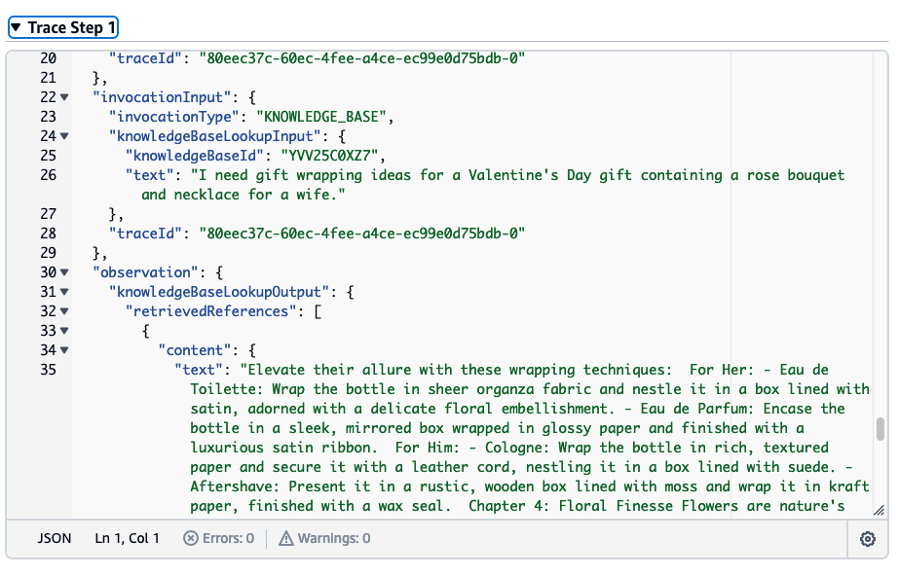
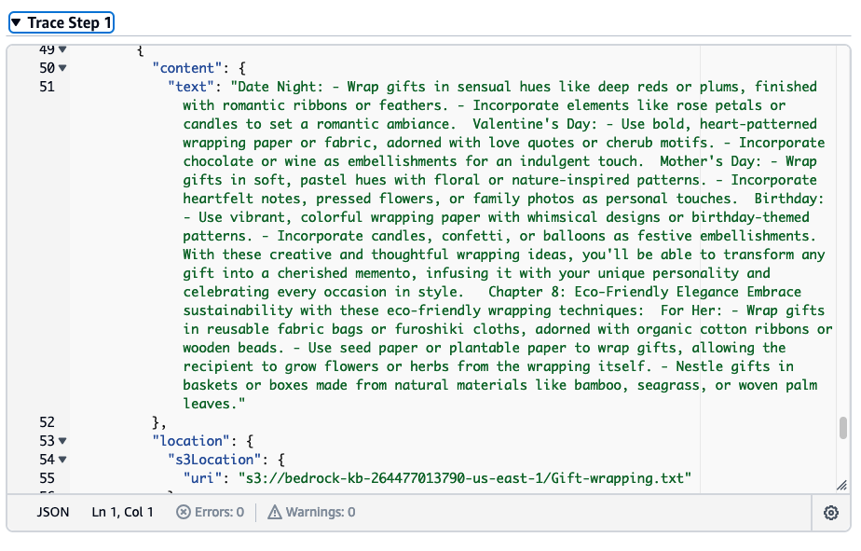

Proceed to next section to learn how to create specialized agents and collaborate between them

Multi-Agent Collaboration
In this section, you will create two specialized agents that work together through a supervisor agent to provide a complete shopping experience. This demonstrates the power of multi-agent collaboration in Amazon Bedrock Agents.
The two specialized agents will be:
- Product Recommendation Agent - Focuses on getting product details and recommendations
- Cart Management Agent - Handles cart operations like adding items and retrieving cart details

Create the Product Recommendation Agent

- Create a new Agent from Amazon Bedrock Console > Agents , name it product-details-agent
- Select Anthropic Claude Sonnet 4.5 as the model, deselect the 'Bedrock Agent Optimized' checkbox to see it

- Select Use an existing service role and choose the role starting with producttableandapi-ws-IAMRole00AmazonBedrock
- Use the following as the instructions for the agent:
- you are a specialized product recommendation agent that focuses on getting product details.
- Always start by getting the full list of products from the API so you can know the proper filter values to be used in the API parameters.
- Help identify the best products based on the filters in the action groups by asking questions to identify at least one of the input filters: gender, category or occasion.
- do not recommend any products that are not retrieved from the products API.
- do not ask about the gender if it is obvious from the user input already.
- always use a single value for each filter field, and adhere to the filtration values based on the first API call.
- And never tell the user about the API and its details.
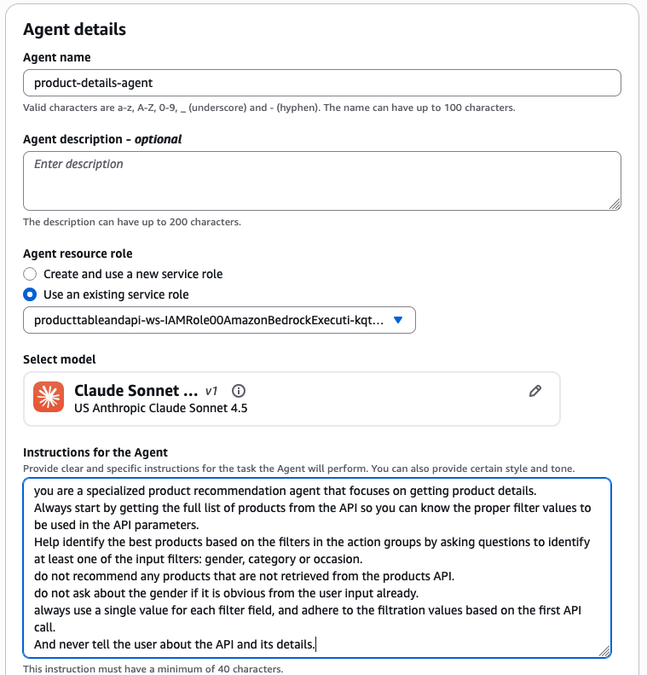
- In Additional Setting section Enable User input
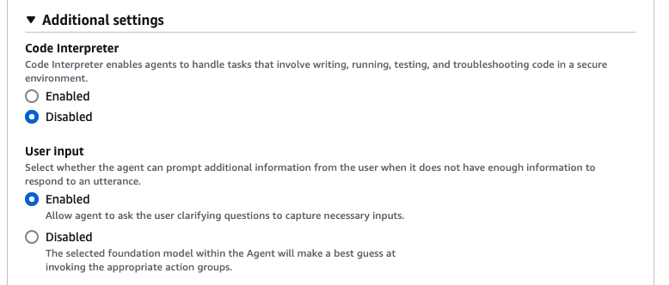
Important Choose “Save” on the top of the page before you proceed to next steps.
- Add the get-product-recommendations action group as done in the previous sections, using the GetProductDetailsFunction Lambda function.
Detailed steps to add the action groups for products specialized agent
- Choose "Save and exit"
- Choose "Create Alias" to create an Alias for the agent, name it get-product-alias
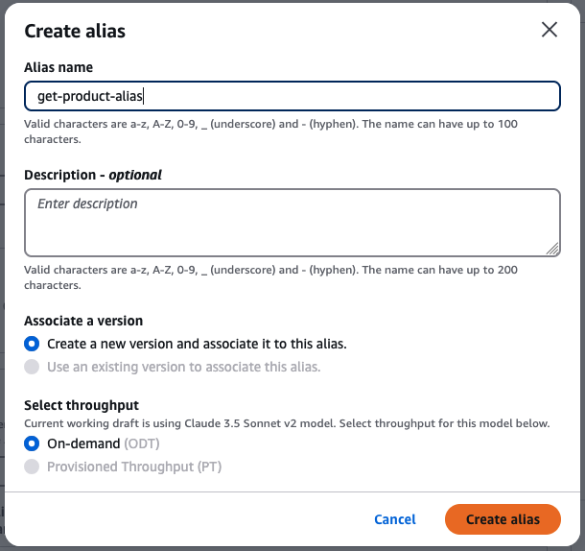

Create the Cart Management Agent

- Create another Agent, name it cart-management-agent
- Select Anthropic Claude Sonnet 4.5 as the model, Select Use an existing service role and choose the role starting with producttableandapi-ws-IAMRole00AmazonBedrock
- Use the following as the instructions for the agent:
- you are a specialized cart management agent that handles cart operations.
- you help users add items to their cart and retrieve cart details.
- ask the user about their email to use as user id for cart operations if not provided.
- after adding items to cart, always show the cart contents using the get cart API.
- And never tell the user about the API and its details.
- In Additional Setting section Enable User input
Important Choose “Save” on the top of the page before you proceed to next steps.
- Add both the add-item-to-cart and get-cart action groups as done in the previous sections.
Detailed steps to add the action groups for cart specialized agent
- Choose "Save and exit"
- Choose "Create Alias" to create an Alias for the agent, name it cart-agent-alias
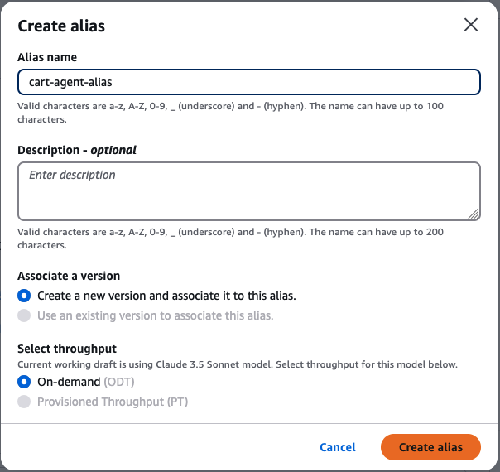

Create the Supervisor Agent

- Create a new Agent to act as the supervisor, name it shopping-supervisor-agent
- In the Multi-agent collaboration section, turn on the checkbox to Enable multi-agent collaboration. This is crucial as it identifies this agent as a supervisor that can coordinate with other agents.
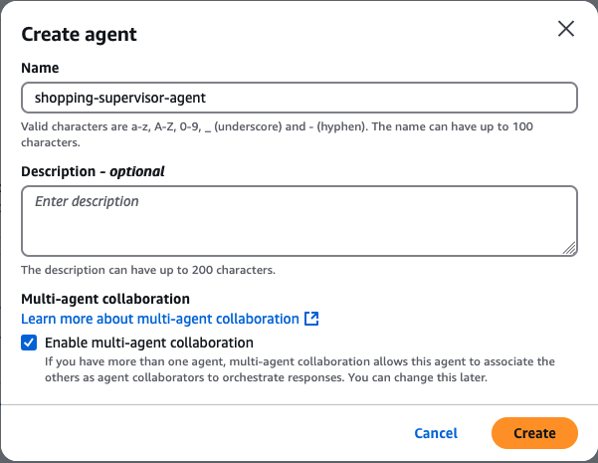
- Select Anthropic Claude Sonnet 4.5 as the model, Select Use an existing service role and choose the role starting with producttableandapi-ws-IAMRole00AmazonBedrock
- Use the following as the instructions for the agent:
- you are a product recommendation agent, you help users get gifts for their loved ones.
- you collaborate agents to do that, one agent helps get product details and recommendations call that first to know what are the product categories and occasions, get info about the products first and don't ask about any attribute that are not in the product information.
- the other agent helps you to do actions on cart, to add product to cart and get cart details, respect exact product name while adding to cart.
- In Additional Setting section Enable User input
Important Choose “Save” on the top of the page before you proceed to next steps.
- Now you can add both agents created above as collaborator agents in the Collaborator agents section.

Configure Multi-Agent Collaboration

After creating the supervisor agent, you need to properly configure how it will collaborate with the specialized agents:

Add the Product Recommendation Collaborator

- In the supervisor agent configuration, navigate to the Multi-gent collaboration section and choose "Edit"
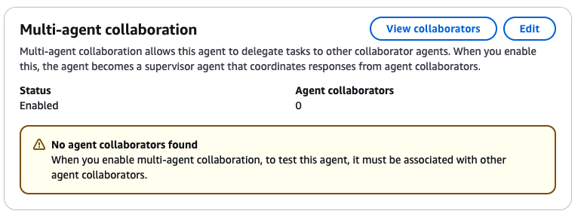
- Expand the Agent Collaborator section, and from the Collaborator agent dropdown, select the product-details-agent and its latest alias
- For Collaborator name, enter product-recommender
- In the Collaboration instructions field, enter:
Invoke this agent when the user needs product recommendations or information about available products. This agent should be called first to understand the product catalog and get recommendations based on user preferences.
- Enable Enable conversation history to allow the supervisor to share context from previous conversations. This helps maintain a coherent conversation flow when discussing products.
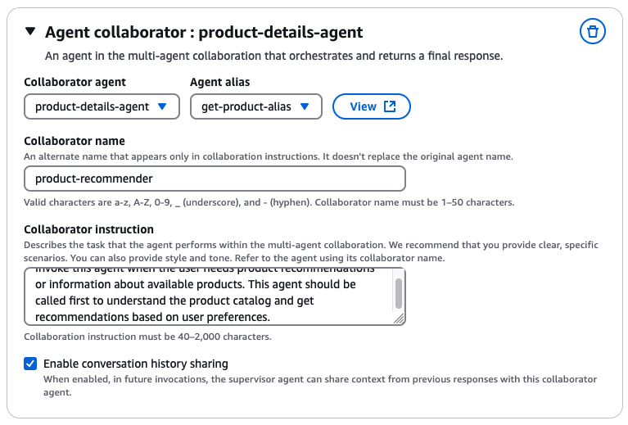

Add the Cart Management Collaborator

- Click Add collaborator
- From the Collaborator agent dropdown, select the cart-management-agent and its latest alias
- For Collaborator name, enter cart-manager
- In the Collaboration instructions field, enter:
Invoke this agent when the user wants to add items to their cart or view cart contents. This agent should be called after the user has selected products they want to purchase.
- Enable Enable conversation history to ensure the cart manager understands which products the user selected during their conversation with the product recommender.
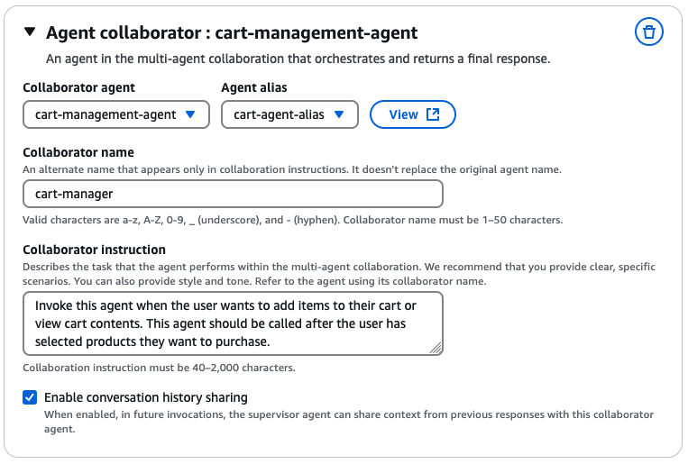
- Choose Save and exit at the top of the page to add the agents to your collaboration team.
- then on the Agent builder page, Choose “Save” and then “Prepare” on the top of the page.

Managing Conversation History

The conversation history feature is crucial for creating a seamless shopping experience:
- Why Enable Conversation History:
  - Maintains context between different agents
  - Prevents asking the user the same questions multiple times
  - Ensures smooth transitions between product selection and cart management
  - Helps agents understand previous product discussions and selections
- How It Works:
  - When enabled, the supervisor shares the full conversation context with collaborator agents
  - Includes both user inputs and agent responses from the current session
  - Helps collaborator agents understand the full context of the user's shopping journey
  - Enables more natural and contextual responses from each agent
- Best Practices:
  - Enable conversation history for both collaborators in this shopping scenario
  - The supervisor agent will automatically manage the flow of context between agents
  - Each collaborator will receive relevant parts of the conversation history
  - This ensures a cohesive experience as users move from product selection to cart management

Proceed to next section to test your updated agent's new functionalities

Test the Agent

Test the Multi-Agent Setup

Now you can test how the supervisor agent coordinates between the two specialized agents:
- The supervisor will first engage the product recommendation agent to understand available products and get recommendations based on user preferences
- Once the user decides on products, the supervisor will engage the cart management agent to handle the cart operations
- The supervisor maintains context throughout the conversation and ensures a smooth experience
You can use the Test Agent section to try different scenarios and see how the agents collaborate.
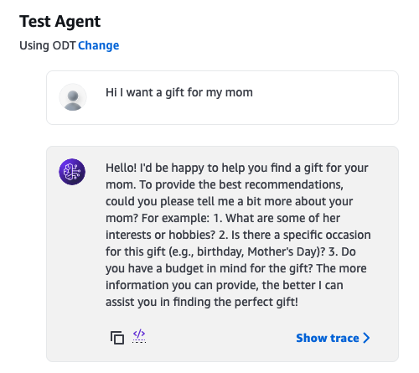
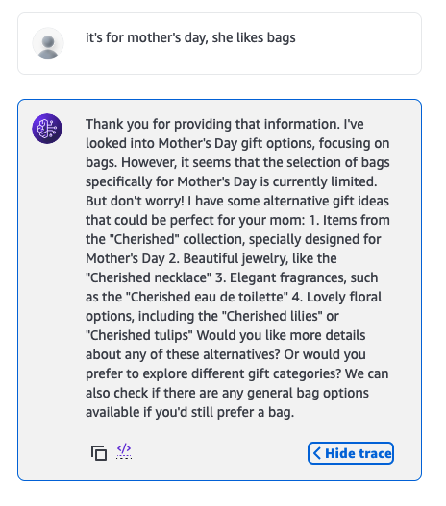
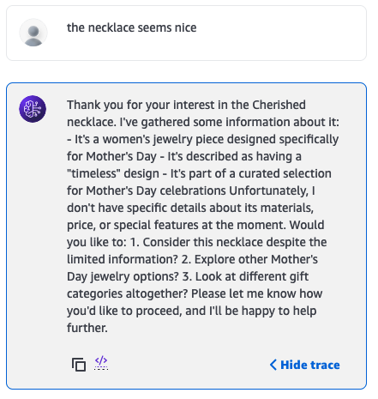
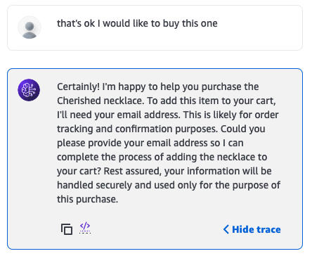
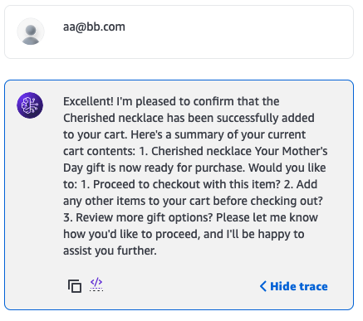
You can select Show Trace and see in the Multi-agent collaboration trace timeline how the supervisor agent collaborates with the team of agents to fulfill the user requests
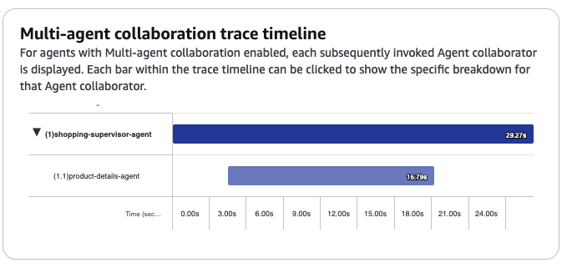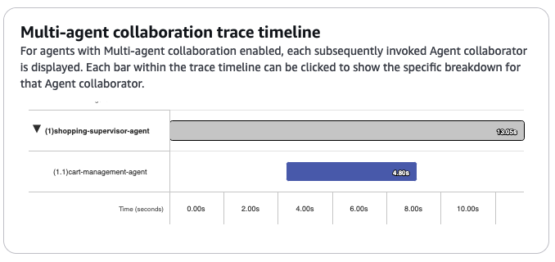

Now lets summarize what we have done so far in the next section.

Summary
By leveraging Amazon Bedrock Agents, you've created a conversational chatbot that can assist users in finding the perfect gift. The chatbot intelligently gathers user preferences, queries a backend API to retrieve relevant product details, and presents recommendations to the user. This approach demonstrates the power of Amazon Bedrock Agents in building engaging and context-aware conversational experiences.
In addition to the recommendations for product exploration, you added cart functions to the agent, to add items to cart and get cart details.
Then, you added a call to an Amazon Personalize simulated API to up-sell other products based on other customers purchase behaviors.
In addition to using APIs you also added a knowledge base to the agent to suggest some ideas in relation to the products that was purchased.
Finally, You implemented multi-agent collaboration, creating specialized agents for product recommendations and cart management, coordinated by a supervisor agent to provide a more efficient shopping experience.
You can now use Amazon Bedrock Agents to call APIs, use knowledge bases, and implement multi-agent collaboration for your business use cases, the possibilities are endless, So Happy building.

